Octal to decimals
0 1 2 3 4 5 6 7----OCTALS
To convert from octal to decimal
You must do the power of 8 multiplied to the decimal digit
37246₈
(3x8⁴) + (7x8³) + (2x8²) + (4x8¹) + (6x8⁰)
12288+3584+128+32+6 = 16038₁₀
Decimal to octal
To convert from decimal to octal
You must divide the decimal with eight every time until you have a residue (se para la división cuando el número no sea divisible entre 8 y se cogen todos los números que sobran de abajo hacia arriba)
323₁₀
323/8= 40 sobran 3
40/8= 5 sobran 0
503₈
Octal to binary
You must convert the octal to decimal and then divide into 2
4316₈
(4x8³)+(3x8²)+(1x8¹)+(6x8⁰)
2048+192+8+6= 2254₁₀
Then you have to divide between 2
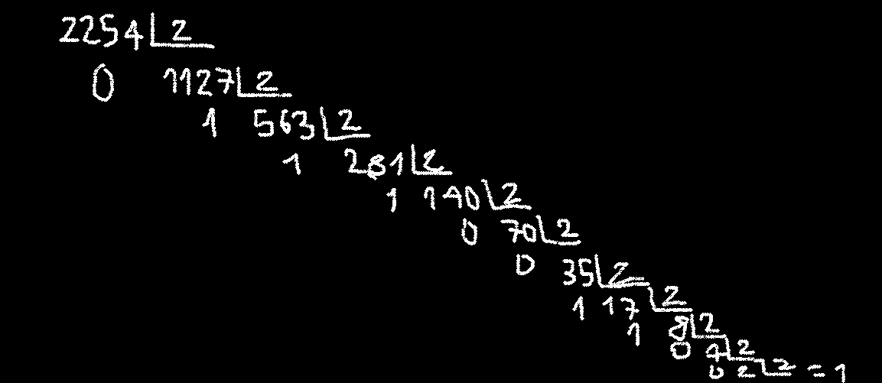
100011001110

